**Student Name : Santosh Acharya**

**Student Id : C0930325**

**Program Code : CSD 2206**

**Assignment 5**

**Solution :**

1. **Query to display all the criminal aliases beginning with letter B.**

**SQL query :**

* SELECT * FROM aliases where ALIAS LIKE ‘B%’;

**ALIASES Table**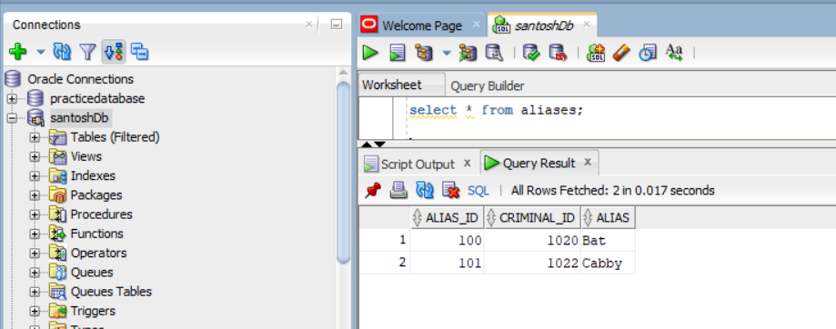

**Output of the query**

Output for the SQL

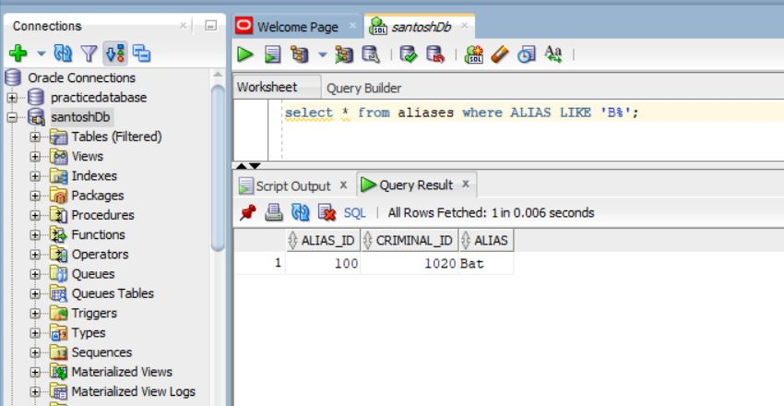

1. **Query to list of all crimes that occurred in November 2008**

* Alter session for date is used to rearrange the date in the table.

**SQL query**

* ALTER SESSION SET NLS_DATE_FORMAT = ‘YY-MON-DD’;
* SELECT crime_id as “santosh_crime_id”, criminal_id, date_charged, classification from crimes where date_charged like ’08-NOV%’;

**Crimes table**

This are the data that will be displayed by the query

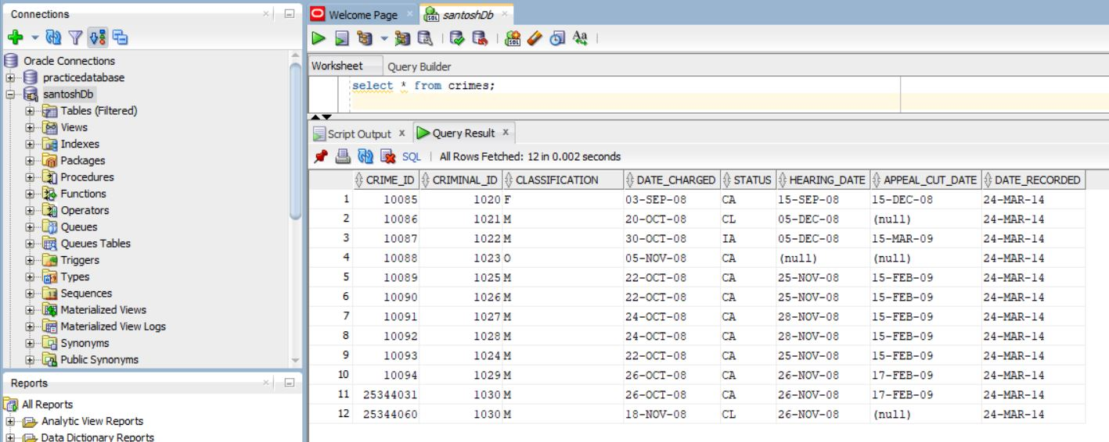

**Output after the query**

Output of the query

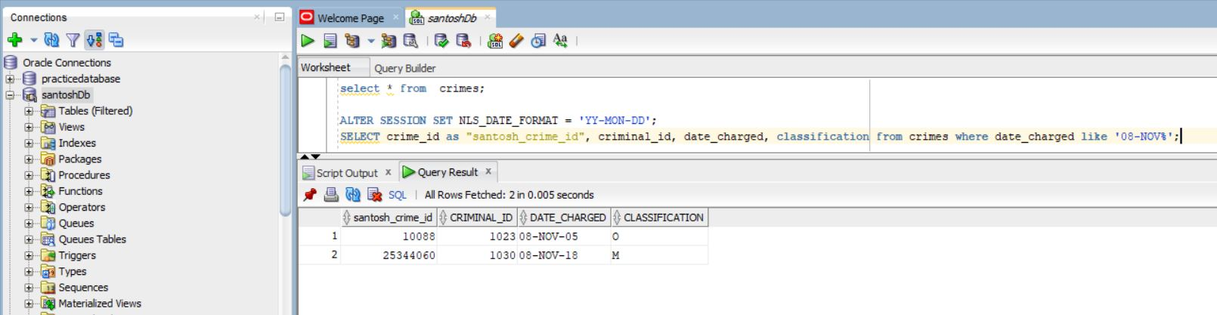

1. **Query to list all criminal with the status CA or IA**

**SQL query**

* SELECT crime_id as “santosh_crime_id”, criminal_id, date_charged, status from crimes where status in (‘CA’,’IA’);

**Crimes table**



**Output after the query**

Output of the query

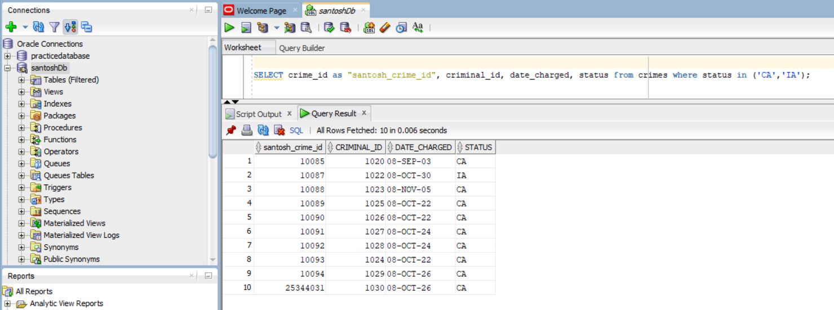

1. **Query to list all criminal classified as felony**

**SQL query**

* SELECT CRIME_ID AS “Santosh_crime_id”, criminal_id, date_charged, classification from crimes where classification = ‘F’;

**Crimes table**

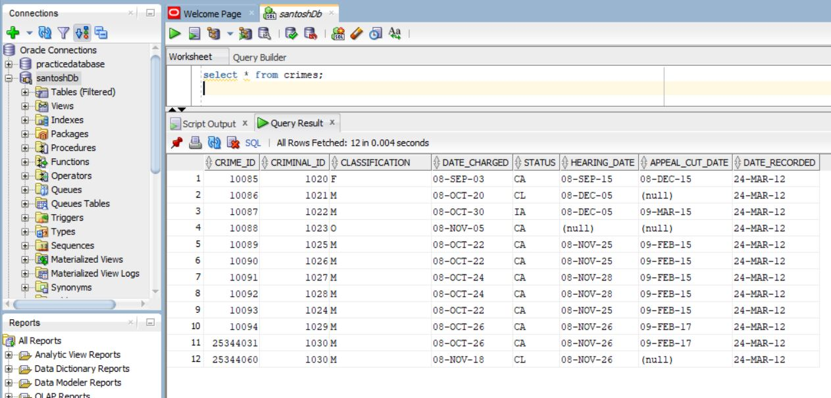

**Output after the query**

Output of the query

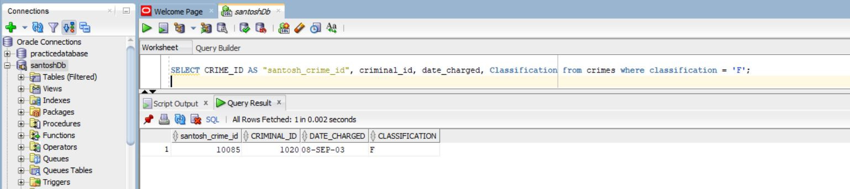

1. **Query to list all crimes with the hearing date more than 14 days**

**SQL query**

* SELECT CRIME_ID AS “Santosh_crime_id”, criminal_id, date_charged, hearing_date from crimes where hearing_date – date_charged > 14;

**Crimes table**

This are the data showed after the above query is triggered



**Ouput after the query**

Output of the query

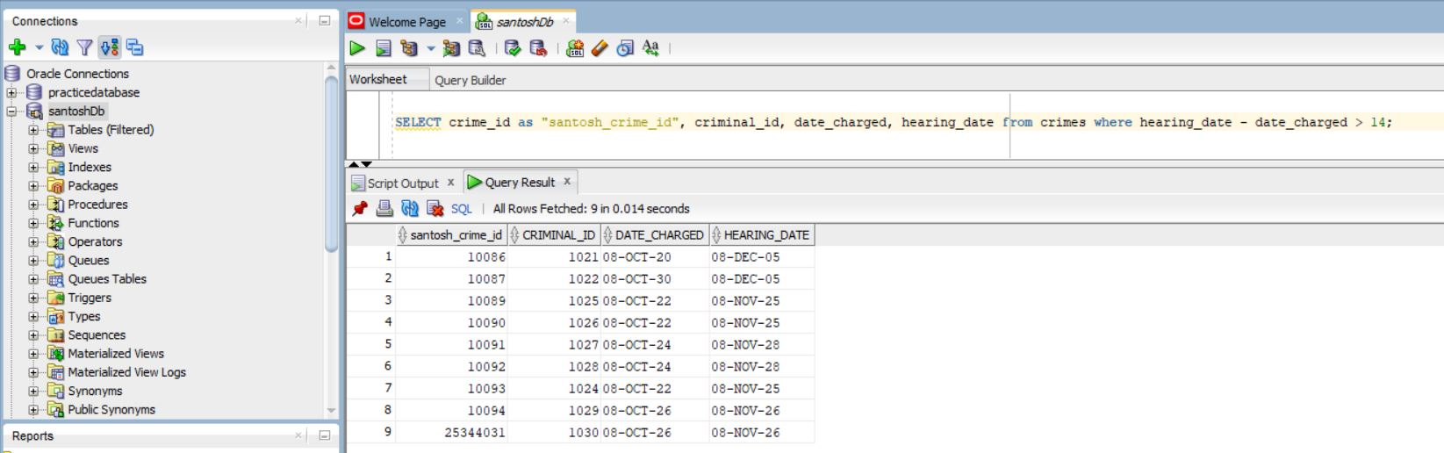

1. **Query to list all criminals with the zip code 23510**

**SQL query**

* SELECT CRIMINAL_ID AS “Santosh_criminal_id”, last, zip from criminals where zip = 23510;

**Criminals table**

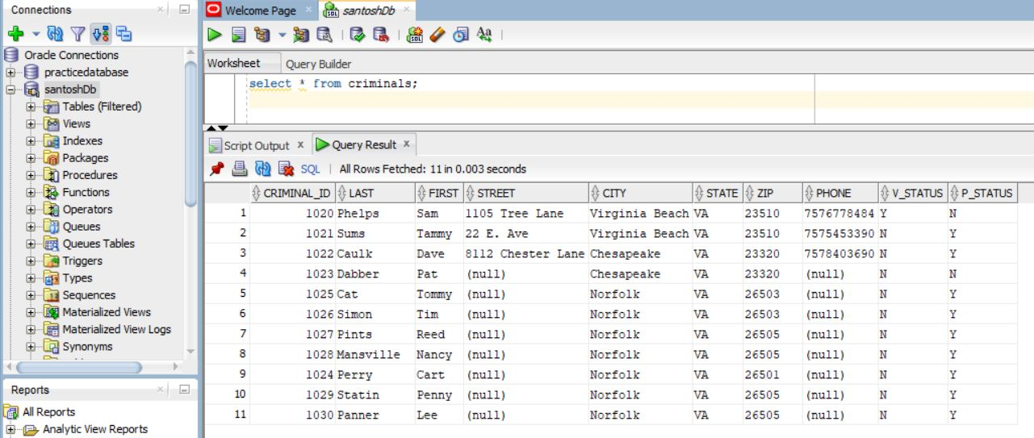

**Output after the query**

Output of the query

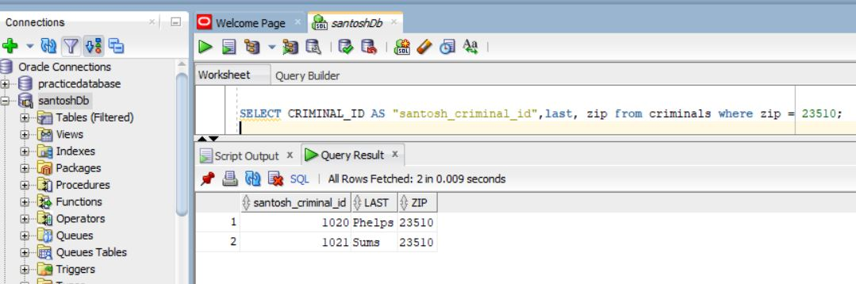

1. **Query to list all crimes that don’t have a hearing date scheduled**

**SQL query**

* SELECT CRIME_ID AS ”santosh_crime_id”, criminal_id, date_charged, hearing_date from crimes where hearing_date is null;

**Crimes table**



**Output after the query**

Output of the query

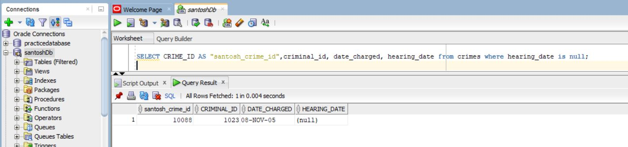

1. **Query to list all sentences with a probation officer assigned**

**SQL query**

* SELECT sentence_id as "santosh_sentence_id", criminal_id, prob_id from sentences

where prob_id is not null Order by prob_id, criminal_id;

**Sentences table**

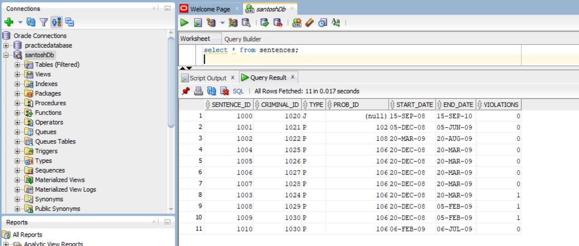

**Output after the query**

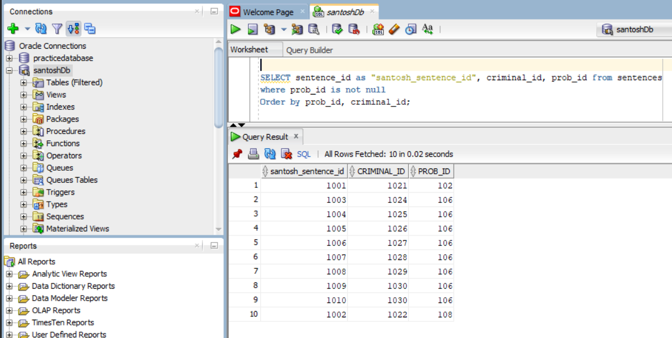

Output of the query

1. **Query to list all crimes that are classified as misdemeanors (classification =’M’) and are currently in appeal (stat is ‘IA’)**

**SQL query**

SELECT crime_id as “Santosh_crime_id”, criminal_id., classification, status from crimes where classification = ‘M’ and status in (‘IA’)

**Crimes table**



**Output after the query**

Output of the query

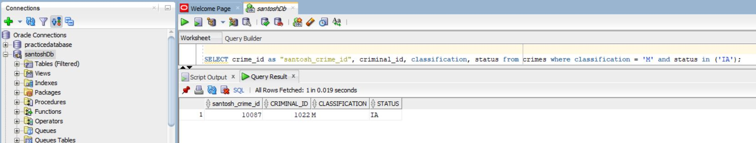

1. **Query to list all crime charges with a balance owed. List the charge ID, crime ID, fine amount, court fee, amount paid, and amount owed.**

* The COALESCE() function returns the first non-null value in a list.

**SQL query**

* SELECT charge_id AS "santosh_charge_id", crime_id, fine_amount,court_fee,amount_paid, (fine_amount + court_fee - COALESCE(amount_paid, 0)) AS "amount_owned" FROM crime_charges WHERE fine_amount IS NOT NULL AND court_fee IS NOT NULL and (fine_amount + court_fee - COALESCE(amount_paid, 0)) > 0;

**Crime Charge table**

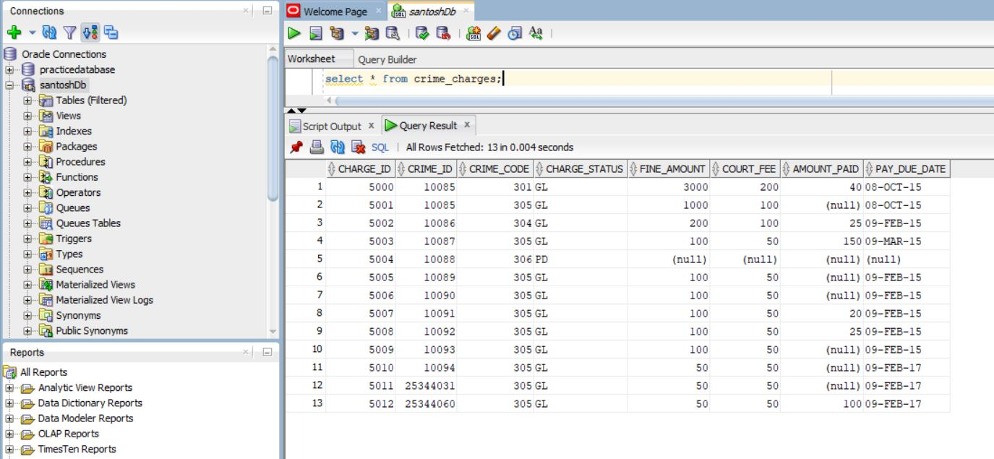

**Output after the query**

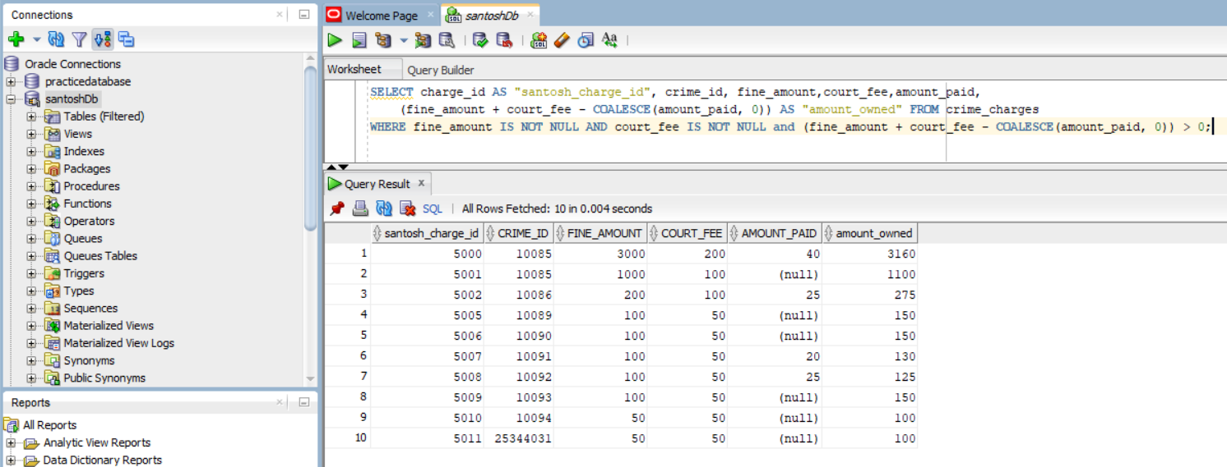

Output of the query